Assignment Web 3: Style Sheets

CS-248 Web and Internet Programming

**Due: Tuesday February 14th before class** in dropbox for Assignment Web 3 on Learn@UW-Stout

Value: 50 Points

**Requirements (20 points)**:

Create an external cascading style sheet to format the xhtml document from Assignment Web 1 Schedule Table. See the example below. Be sure to link the style sheet to the original document.

1. Change the color of h1 (name) to blue and text-align to the center.
2. Make the background-color for td and th cells light yellow.
3. Center the text-align in all td elements.
4. The cells for all of the same courses should have its own unique color using a class attribute.
5. Use an id to color a unique cell (like my department meeting).
6. Set the list-style-type for the li to square.

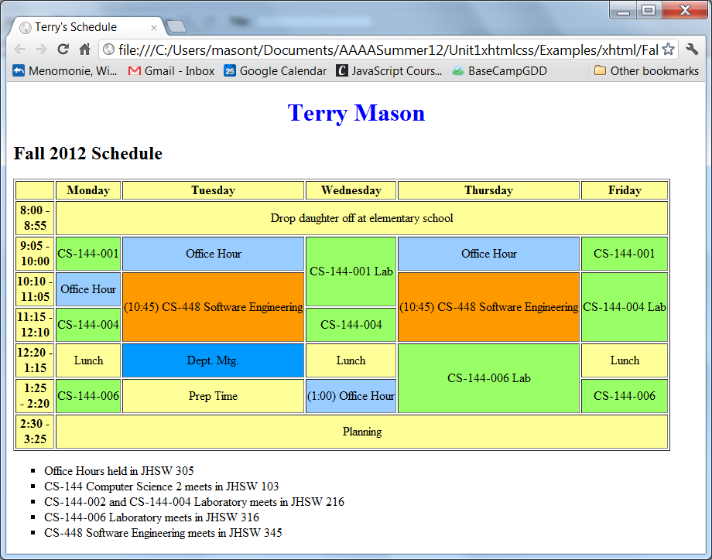

**Requirements (30 Points)**:

Link to the above Style Sheet from your Web 2 HTML document. Add to the external cascading style sheet to format the document from Assignment Web 2.

1. Change the color to red for all h2 elements.
2. Make all h1 elements font blue and centered.
3. Use classes to specify the first item in an unordered list to have a list-style-type to be a disk, the second to be a square, the third a circle, and all others a unique symbol. Note: the order must be the same for all unordered lists.
4. Format all words that are italics, underlined, or bold with the span tag. Add some bold words if you need to.
5. Create id values of music, hobby, and web for the matching ordered line items. Use these to give each list a unique color and font-family.
6. Change the color of the text to red when the mouse moves over the website links. (hover)
7. Set the width of the image to 25% and add a black border.
8. Align the outer (formatting) table cells with content starting in the top left corner of the cells. Set the two columns to equal width.
9. Align the cells (tds) in the nested table (use an id name in a div tag to identify only the inner table) to be centered in the middle.
10. The cell for all of the same courses should have its own unique color using a class attribute.

Submit both the html, image, and css files **zipped in a single folder** (save all files in a folder and right click->send to compressed) and put the zipped folder in the dropbox.

Your assignment will be graded based on your skills used in css that meet the requirements above. Please feel free to add your own formatting above and beyond these requirements.